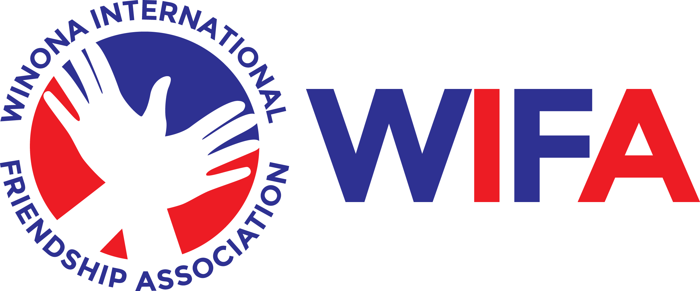

Interview: May 28th, at 6:30PM. Location: Winona City Hall-Council Chambers.

Dear _____________________________.

Congratulations! Thank you for applying to be an Ambassador to Misato, Japan. After careful screening of your letter of application and the letters of recommendation, we are pleased to inform you that you have been selected to be interviewed to be an ambassador.

The dates of the interviews are Tuesday, May 28th, 2024. All interviews will take place at City Hall on the third floor of City Hall. Bring a self-addressed stamped envelope. Be sure to put your home address in the middle and use your home address in the upper left-hand corner for the return address.

You will need to prepare a speech to begin your interview. Limit your speech to two minutes. Choose ONE of the topics listed below for your speech. Practice your speech ahead of time! You may have a notecard with speech notes written on it.

- My hero is ..... Why?
2. I would encourage my friends to read the novel ________________ because .........
3. I can change the world by ...........
4. Music or another artistic endeavor makes me smile because..........
5. My favorite subject in school is ....... Explain why.
6. Outside of school, I like to be involved in __________ because....

Good luck with your interview! You get one chance to make a first impression. Dress appropriately!!!!!

Sincerely,

Misato, Japan Trip Review Committee

